**Exercises 6**

1. In MATLAB, input the following matrix，and use this matrix to answer the following questions :



a. Construct a 4 × 3 matrix **B**，its elements is the second column through 4-th column of A.

b. Construct a 3 × 4 matrix **C**，its elements is the second row through 4-th row of A.

c. Construct a 2 × 3 matrix **D**，its elements is the first two rows and last three columns of A.

1. In MATLAB, find the length and absolute value of the following vectors:

a. **x** = [2, 4, 7]

b. **y** = [2, –4, 7, -6]

1. Construct following matrix A and let B=ln(A’):

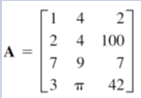

Use MATLAB to find the following:

1. Construct a matrix **C**，it is the transpose of A.
2. Construct a matrix **D,** deleting **2-nd row of A.**
3. Add a column with values 1 to the 2-nd column of D.
4. Extracting 1st and 3th column of A and put it into the matrix E.
5. Construct vector **x,** its elements is the only second row of **B**.
6. Calculate the sum of all the elements of **x.**
7. Pointwise multiplication of the 2-nd row of A and 3-th column of B.
8. Pointwise multiplication of the 1st row of A and 3-th column of B.
9. Find the maximum, minimum and summation values of the resulting vector in h.
10. The following table shows the cost of a product and the output of the four seasons for each business year. Using MATLAB to find (*a*) the cost of materials, labor, and transportation for each season. (b) the total cost of materials, labor, and transportation for each year. And (*c*) total costs of each season.

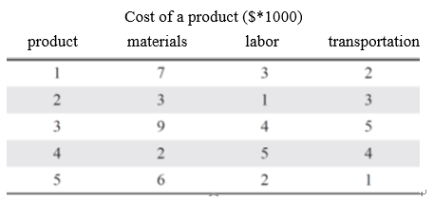

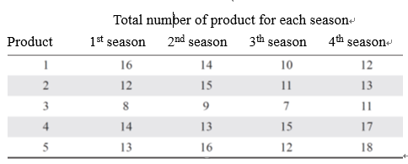

1. Cables of length *Lc* support a beam column of length *Lb* that remains level when the end of the beam column hangs an object with weight W. According to the law of statics, the tension T of this cable can be calculated



Where D is the distance from the connection cable to the beam column. Refer to the following figure

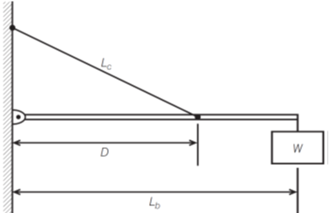

1. Given that *W* = 400 N，*Lb* = 3 m, and *Lc* = 5 m，use pointwise operation and ‘min’ function to find the distance D which lead to the minimum tension T.
2. Plot the relationship between the tension T and the distance D.
3. Aircraft **A** flew east at a rate of 320 mi/hr and aircraft **B** flew south at a rate of 160 mi/hr. The position of the aircraft at 1 pm is shown in the following Figure.

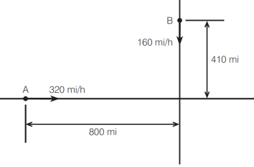

1. Find the distance D between two airplanes as a function of time. D is plotted against time until D reaches its minimum value.
2. Given the following matrices



Use the MATLAB to verify the following properties:

1. The association property:



1. The distribution property :



**Exercises 7**

1. To rewrite newton’s method in book (sec. 7.1 p. 164) by using (for & if break)

Ans:

% excludes zero roots!

steps = 0; % iteration counter

x = input( 'Initial guess: '); % estimate of root

re = 1e-8; % required relative error

myrel = 1;

for steps=1:19

xold = x;

x = x - f(x)/df(x);

steps = steps + 1;

disp( [x f(x)] )

myrel = abs((x-xold)/x);

if myrel <= re

break;

end

end

if myrel <= re

disp( 'Zero found at' )

disp( x )

else

disp( 'Zero NOT found')

end

1. Function handle: (a) Find the minimum value for the function , for the interval of . (Ans: (x,y)=(2.515, 9.0). (Use fminbnd)
2. Use fplot to plot this function for the interval of .
3. Write this function as the parametric form, that is

, where c is the parameter.

Do the same thing as (a) & (b), by given c=2.5.

1. (a) Write a script newquot.m which uses the Newton quotient [*f (x* + *h)* −*f (x)*]*/h* to estimate the first derivative of *f (x). using small values of h=*10−2*. *

*(b)* Rewrite newquot as a function M-file able to take a handle for *f (x) & h value* as an input argument. (ref to p.172)

1. Exercise 7.5 using white loop.
2. Exercise 7.6.

**Exercises 9**

1. (a) Exercise 9.1.

(b) use the Edit plot to insert the ‘title’ and ‘legend’ of the figure & change the line type.

1. Draw the surface shown in Figure 9.7 with a finer mesh (of 0.25 units in each direction), using

[x y] = meshgrid(0:0.25:5); (the number of mesh points in each direction is 21).

1. The initial heat distribution over a steel plate is given by the function

*u(x, y)* = 

Plot the surface *u* over the grid defined by

−2*.*1 ≤ *x* ≤ 2*.*1*,* −6 ≤ *y* ≤ 6*,*

where the grid width is 0.15 in both directions. You should get the plot shown in

Figure 9.8.

1. Use the following command:

figure, plot(x,sin(x), x, cos(x), 'om--')

to create the figure, use the graphic handle to change the properties of two chartlines.

1. Use the handle graphics to create an animation of the line plot. FOR x=0:5*pi, eith step pi/20. (ref to the script in p.222)